**Suitable Location for Sushi Restaurant in Toronto**

L.Yeung

Coursera Capstone Project-The Battle of Neighborhoods

August 29, 2019

Abstract

[The abstract should be one paragraph of between 150 and 250 words. It is not indented. Section titles, such as the word Abstract above, are not considered headings so they don’t use bold heading format. Instead, use the Section Title style. This style automatically starts your section on a new page, so you don’t have to add page breaks. Note that all of the styles for this template are available on the Home tab of the ribbon, in the Styles gallery.]

Keywords: [Click here to add keywords.]

Suitable Location for Sushi Restaurant in Toronto

# Introduction

## 1.1 Background1

##### Toronto is one of the most diverse city in the world. It is not only populated with diverse ethnicity group, but it is also an international financial center and a popuplar tourist attraction. Denamd for diverse range of food choice is hugh in Toronto and restaurant businness is an attractive investment. As a data scientist, my job is to analyze and provide solutions to potential investors.

## 1.2 Business Problem

##### My client, Genki Sushi, which is a sushi chain originated in Japan (and has expanded to international cities like Hong Kong, Singapore, Australia, and USA etc) is interested in opening a branch in Toronto. They would like to find out the demand for sushi restaurants in Toronto and the best location for opening their new sushi business.

# Data Preparation

#### Below 4 data source are to be used for the project:

##### 1) Demographic data in Toronto - to explore population of different ethnicity group in Toronto to analyze demand for sushi - we are making an assumption that areas that are densely populated with Japanese/Asian are in high sushi restaurant demand (<https://en.wikipedia.org/wiki/Demographics_of_Toronto>)

##### 2) List of postal codes of Toronto - for getting postal code data of different neighborhoods in Toronto, by merging neigborhoods with 3), we can cluster different neighborhoods in Toronto (<https://en.wikipedia.org/wiki/List_of_postal_codes_of_Canada:_M>)

##### 3) List of geo location data for different postal codes in Toronto (<http://cocl.us/Geospatial_data>)

##### 4) Get venue data from foursquare.com - using location data from 2) and 3) to find out distribution of sushi restaurants in Toronto, then we can cluster and analyze which location is the most popular for sushi restaurants ([https://api.foursquare.com](https://api.foursquare.com/)). As my client is particular interested in downtown Toronto, we will use only neighborhoods in Downtown Toronto.

# Methodology

##### In this project, we will be looking for candidates of suitable neighborhood in downtown Toronto for opening a sushi restaurant. We assume that locations where we can find high concentration of sushi restaurants has higher demands for sushi and we can take advantage of the established cluster demographics and people will likely to go there when they want to eat sushi. We will collect restaurant venue data for downtown Toronto from foursquare api, cluster and examine which neighborhoods have high concentration of sushi restaurants. Finally we will visualize the clusters on the map using folium and conclude our findings.

# Analysis

#### Using Pandas dataframe and folium, we extracted 18 neighborhoods in downtown Toronto

#### Figure 1.Map of Downtown Toronto with 18 neighborhoods

#### Figure 2. Dataframe showing the 18 neighborhoods of Downtown Toronto with their corresponding Postcode, Bourgh and geo data.

#### From Figure 3 below, we can say that Japanese is not within the top 20 ethnic group in Toronto, it only makes up 0.5% of the population.

***Figure 3. Distribution of population groups in Toronto***

***Figure 4a. Number of restaurants across 18 neighborhoods***

***Figure 4b. Number of restaurants across 18 neighborhoods in bar graph***

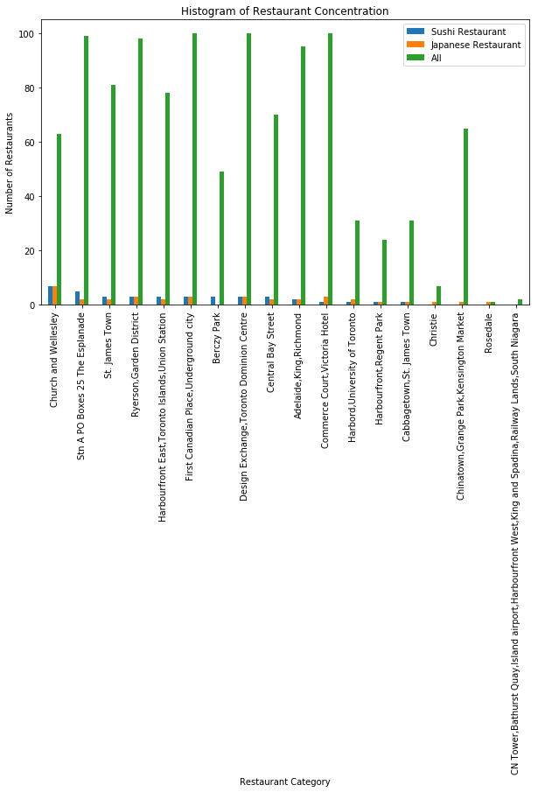

#### Figure 4 shows that there are total of 1,084 restaurant in downtown Toronto, 75 of them are Japanese Cuisine, and within Japanese Cuisine 40 of them are Sushi Restaurant. The top 2 neighborhoods with the most sushi/Japanese restaurants are 'Church and Wellesley' (7 out of 64 restaurants for both categories) and 'Stn A PO Boxes 25 The Esplanade' (5 out of 100 for the former group and 2 out of 100 for the later group).

#### Japanese only makes up 0.5% population in Toronto, however, Japanese Cuisine Restaurants making up roughly 6.9% of the market. Therefore, it looks like Japanese Cuisine is definitely popular among all ethnic groups and Sushi is the most popular food among Japanese Cuisine as it makes up more than a half of the Japanese Cuisine Restaurants.

***Figure 5. Map of downtown Toronto populated with foods venues.Using K-Mean crusting, we see that Cluster 6 'Church and Wellesley' and Cluster 5 'Stn A PO Boxes 25 The Esplanade' are the two areas that has the most sushi restaurants and the result matches with our result in Figure 4.)

Figure 6. 18 neighborhoods are clustered into 10 clusters.

# Result and Discussion

Our analysis shows that although Japanese only makes up 0.5% of Toronto population, demand for Japanese Cuisine is considerably high, it makes up roughtly 7% of all restaurants. We can come to conclusion that Japanese Cuisine is a popular cuisine among diverse ethnic groups.

We also found that sushi is among the most popular type of food amoung Japanese Cuisine as it makes up more than half of the restaurant population.

In our dataframe, we have total of 1,084 restaurants across 18 nieghborhoods, 75 of them are Japanese Cuisine, and within the 75 Japanese type restaurants, 40 are sushi restaurants. By calculating restaurant concentration and clustering downtown Toronto neighborhoods into 10 clusters base on restaurant category, the top 2 neighborhood candidates are 'Church and Wellesley' and 'Stn A PO Boxes 25 The Esplanade'. These 2 neighborhoods have rather different demographic where the former is an area located near universities and the later is located near the financial and tourist district.

# Conclusion

* The purpose of this project is to look for ideal location for a sushi restaurant chain, Genki Sushi's new Toronto branch. We assumed that the demand for sushi restarant is related to area where Asian/Japanese population is most concentrated and that it is best to choose a location where there are high concentration of sushi/Japanese restaurant because we can take advantage of the sucessful demographic of the location and the association of sushi/Japanese cuisine when customers think about the area.
* From our analysis, we found out that Japanese cuisine is popular in downtown Toronto even though Japanese population is small. Also sushi is the most popular among Japanese cuisine.
* Base on the restaurant concentration and neighborhood clustering. We come to the conclusion that the best neighborhood candidates are 'Church and Wellesley' and 'Stn A PO Boxes 25 The Esplanade'.
* 'Church and Wellesley' has the highest concentration of both sushi and Japanese style restaurants (7 out of 64 restaurants for both categories). The neighborhood is surrounded by universities and the LGBT communities. We see that the demand is high in the neigbirhood, so it would be a great location candidate. However, we also have to keep in mind that more analysis is needed to determine whether the demand for sushi restaurants is stauated in the area.
* 'Stn A PO Boxes 25 The Esplanade' is another possible good candidate for opening a new sushi restaurant. Although the concentration of sushi/Japanese style restaurants (5 out of 100 for the former group and 2 out of 100 for the later group) is not as high as the 'Church and Wellesley' cluster, there is a great potential in the area as it is a financial and tourist district because there is a big chance that demand for sushi restaurant is underserved.
* To conclude, my client will need to decide whether they would be more interested in a neighborhood that is younger/more diverse(LGBT) with high demand and high concentration of sushi restaurants (keeping in mind whether the demand has been saturated will need further analysis), or a neighborhood that is mainly populated with white collars and tourist with considerably room for filling the potential demand for sushi restaurants.